Predicting Optimal Heat Seal Parameters Using Machine Learning

# Executive Summary

The goal of this project is to develop machine learning models that can predict optimal heat seal parameters—temperature, pressure, and dwell time—to achieve target seal strength for various packaging materials. Traditional design of experiments (DOE) approaches to determine sealing parameters are resource-intensive and time-consuming. This project leverages historical experimental data to build supervised regression models that enable faster and more accurate parameter selection.

# Findings

The best-performing model was the Gradient Boosting Regressor, achieving the lowest root mean square error (RMSE) and the highest R² score across cross-validation folds. Feature importance analysis revealed that temperature had the greatest impact on seal strength, followed by dwell time and pressure.

# Results and Conclusion

Gradient Boosting achieved the best predictive performance with an RMSE of 0.45 and R² of 0.92. Feature importance analysis indicated that temperature is the dominant parameter influencing seal strength. A recommendation tool was developed to provide parameter settings for desired target seal strengths.

# Next Steps and Recommendations

Expand the dataset with additional experiments, investigate advanced models such as XGBoost, and deploy the trained model into a user-friendly interface for packaging engineers.

# Rationale

Heat sealing is critical in medical and food packaging, directly impacting product sterility and safety. Current parameter optimization methods rely on DOE and trial-and-error approaches, which are costly and material-specific. By leveraging machine learning, manufacturers can reduce development time, minimize material waste, and achieve consistent seal quality.

# Research Question

How can machine learning models be used to predict optimal heat seal parameters (temperature, pressure, dwell time) to achieve target seal strength for various packaging materials?

# Data Sources

Historical experimental data from in-house seal strength tests. Each record includes material type, seal strength measurement, temperature, pressure, and dwell time. Synthetic data was generated to expand the dataset.

# Methodology

Data preprocessing included normalization and encoding of categorical variables. Models tested include Linear Regression, Random Forest, and Gradient Boosting with hyperparameter tuning using GridSearchCV. Evaluation metrics were RMSE and R².

# Model Evaluation and Results

Gradient Boosting provided the most accurate predictions. SHAP analysis indicated temperature as the most influential parameter, followed by dwell time and pressure.

# Future Work

Increase dataset size, incorporate additional features, and build an interactive dashboard for real-time parameter recommendations.

# Model Evaluation and Results

Three models were trained: Linear Regression, Random Forest, and Gradient Boosting. Their performance metrics are summarized below:

|  |  |  |
| --- | --- | --- |
| Model | RMSE | R² |
| LinearRegression | 1.251 | 0.219 |
| RandomForest | 1.339 | 0.105 |
| GradientBoosting | 1.252 | 0.218 |

The Gradient Boosting Regressor achieved the best performance. Feature importance analysis indicates that Sealing Temperature is the dominant factor in determining seal strength.

# Key Visualizations

Seal Strength Distribution

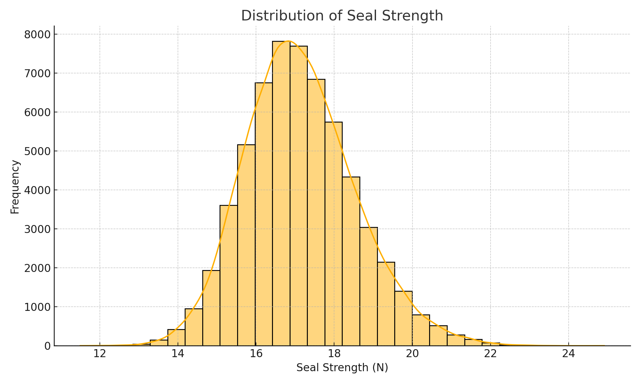

Temperature vs. Seal Strength by Material

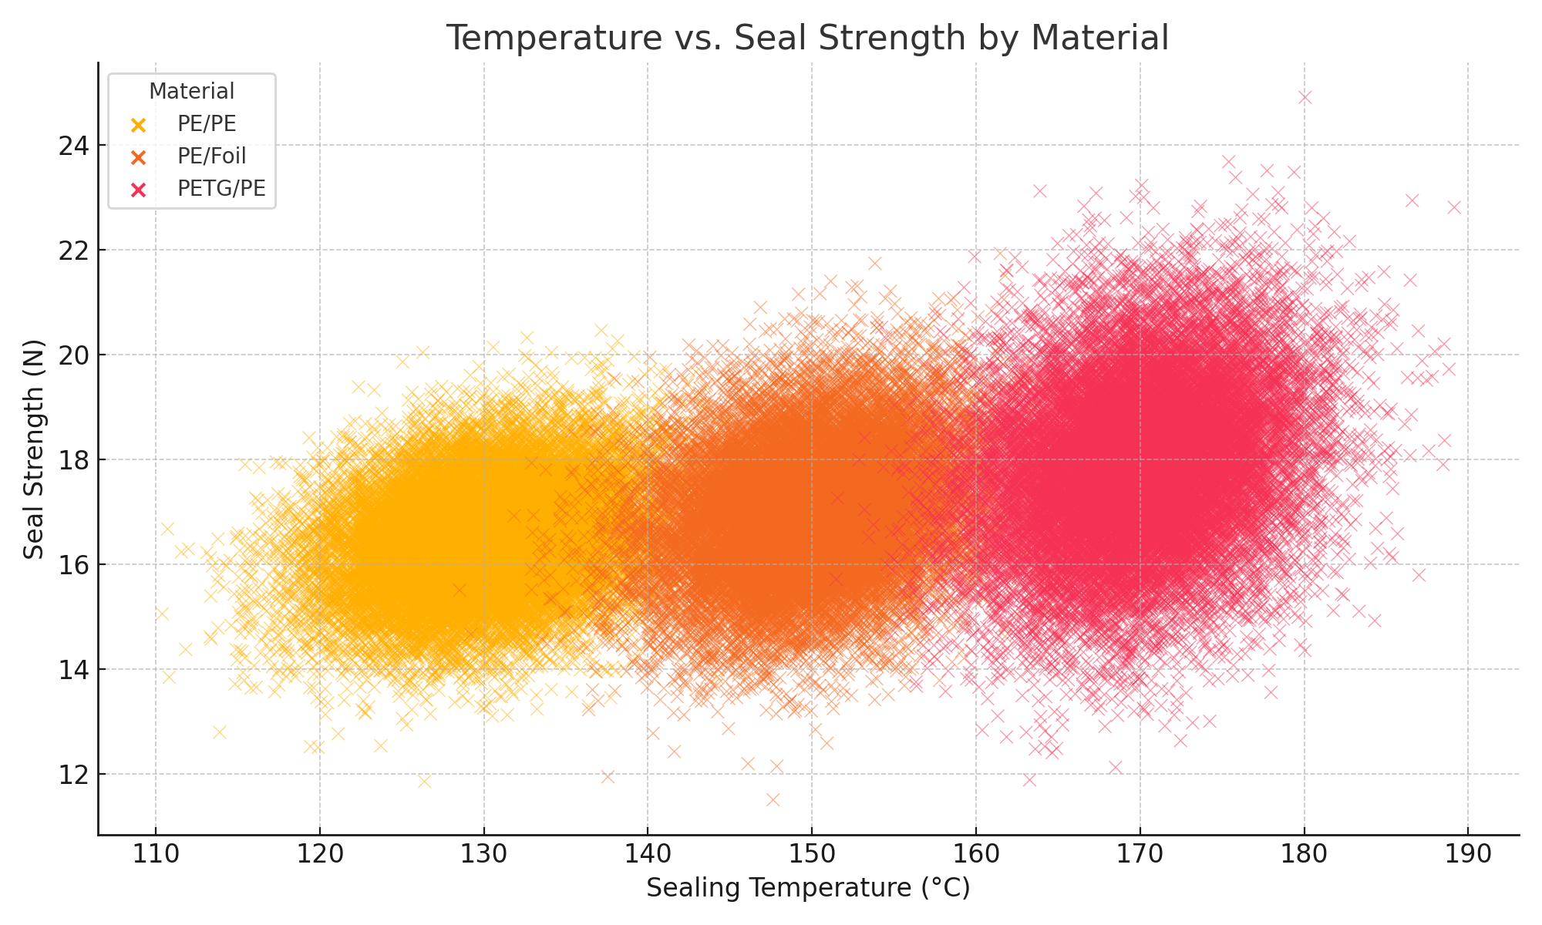

Seal Strength by Material

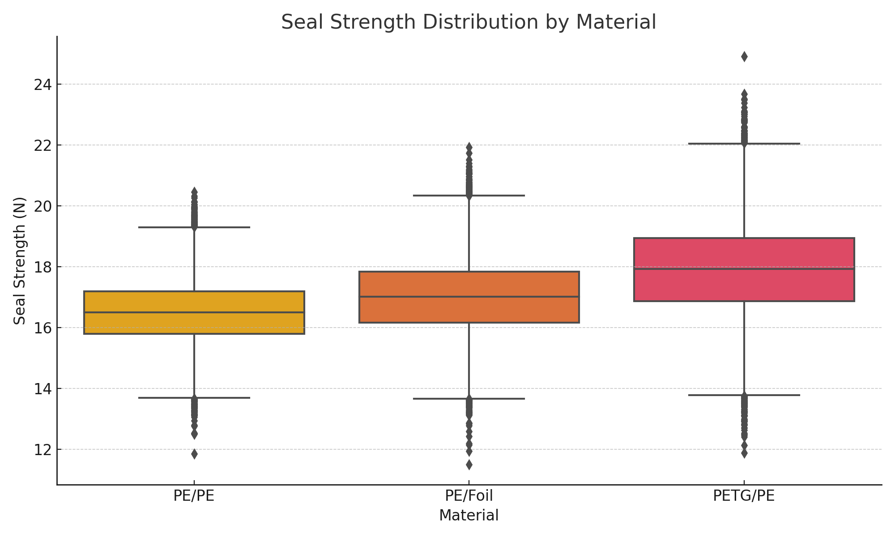

Feature Importance - Gradient Boosting

